
ATAR Biology

Unit 1: Topic 1
Week 2 - Biodiversity

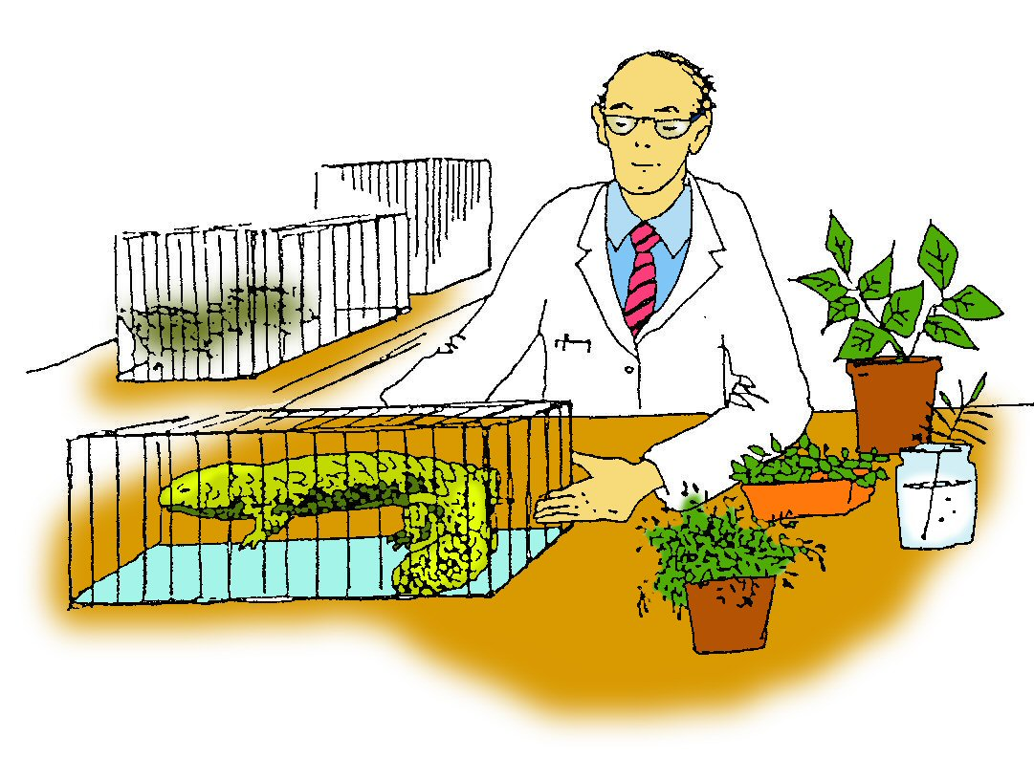

Student Study Notes

Unit content
- Biodiversity includes the diversity of genes, species and ecosystems; measures of biodiversity rely on classification and are used to make comparisons across spatial and temporal scales.
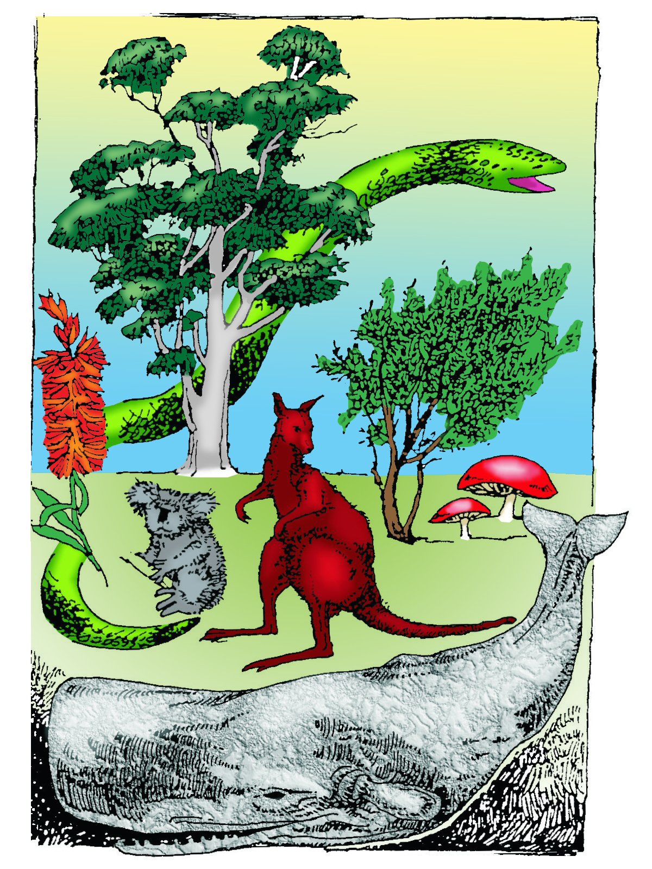
Biodiversity
Biodiversity is the variety of all life forms.
The term biodiversity can be used to describe all of the following:
- the different ecosystems living things are part of
- the variety of living things
- the diversity of genes that living things contain.

Ecosystem diversity
Ecosystems are constantly changing and there is diversity between ecosystems. Ecosystems with the greatest biodiversity are more stable. For example, an ecosystem such as a tropical rainforest is very stable because it has a high biodiversity and resists change.

Species diversity
In biological terms, a species is a group of organisms who are able to interbreed in nature and produce viable, fertile offspring. Species diversity is the variety of species within an ecosystem. Each species provides essential services to that ecosystem. The recycling of organic matter is an essential service provided by saprophytic organisms, such as fungi and bacteria in the soil.
An ecosystem with a high level of species diversity such as a rainforest, is much more stable than an ecosystem with low biodiversity, such as a desert.

Genetic diversity
Genetic diversity is the variety of genes within a species. It allows populations to adapt. However, it is important to remember that the favourable combination of genes or alleles must already be present in the population. If there is a survival advantage these genes will increase in frequency from generation to generation.
Remember: individuals do not adapt to change. It is the population or species as a whole which adapts to change.

Measures of biodiversity
Biodiversity is constantly changing over spatial (space) and temporal (time) scales.

Spatial scales: This refers to how the space is being occupied. Scientists look at spatial patterns to understand the extent of an area and the distribution of the species within it. They look at how the features of a landscape are arranged across the surface of the Earth and seek to find patterns.

Temporal scales: This refers to time. These patterns are studied to provided details about the biodiversity in a certain area over a certain period of time.

Populations, communities, and ecosystems are constantly changing over geographic and evolutionary time scales. These changes are influenced by interactions between living (biotic) and non-living (abiotic) factors.

For example, the geographic or spatial distribution of vegetation types and soil types conform approximately with the observed global climatic patterns.

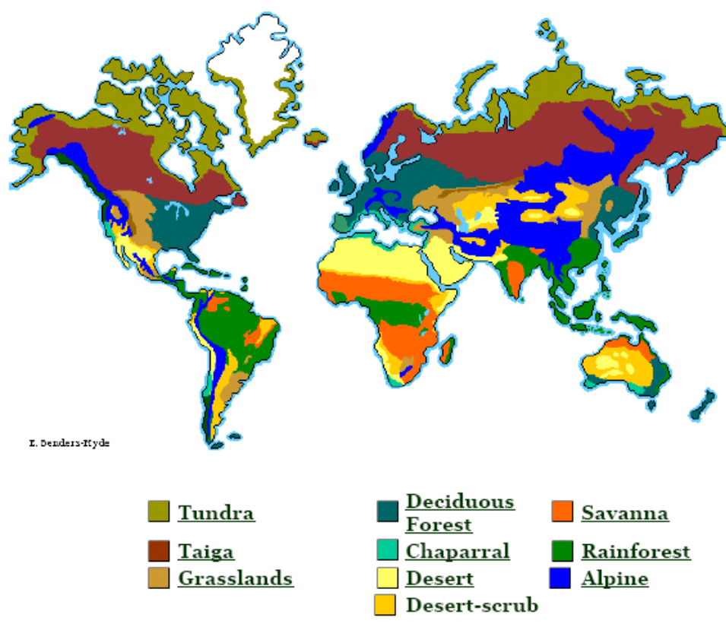

Regional and temporal disturbances may result in a reduction in population size or extinction. A loss of one species may cause the loss of other species and changes in the ecosystem.

In nature, organisms are not distributed at random but form some sort of spatial pattern.
The type of spatial arrangement usually suggests interactions within and between species, such as competition, predation, and reproduction.
On an ecological time-scale, competition can affect the number of co-existing species, but can also lead to the development of traits where individuals best able to compete tend to survive.

On an evolutionary time scale, interactions can lead to biodiversity where in the coevolution of species certain traits can develop. For example, Gastrolobium, also known as the poison pea plant, is found in Western Australia. This plant is deadly to introduced species such as the fox but is not poisonous to native animals in Western Australia. The native animals have coevolved with Gastrolobium and have built up a tolerance to its poison.

PRACTICE QUESTIONS:

- The non-living factors in an ecosystem are termed:
  - biotic
  - abiotic
  - aerobic
  - anaerobic

- There have been occasions when different but closely related species have mated to produce ‘hybrid’ offspring. A common example is the mule that is produced when a horse and a donkey are crossed. Which of the following statements concerning the mating of mules is correct?
  - The mating of mules will not produce offspring.
  - The offspring of mules are capable of mating with both horses and donkeys.
  - If mules mate, the offspring will mostly resemble donkeys.
  - Mules will pass on a blend of horse and donkey features to their offspring.

- Biodiversity can be measured at three different levels. These are:
  - biome, species and habitat diversity.
  - genetic, species and ecosystem diversity
  - species, community and niche diversity.
  - ecosystem, species and individual diversity.

- Which of the following does not maintain biodiversity?
  - Growing a variety of plants on a farm.
  - Protecting all the species in an ecosystem.
  - Removing a predator from the ecosystem.
  - Protecting the habitats in an ecosystem.
5. Identify the most suitable definition of a biodiversity hotspot.
- A biogeographic region that is a significant reservoir of biodiversity and is also threatened with destruction.
- An area with intact natural ecosystems, where both native species and communities are present.
- A biogeographic region with more than 1500 endemic species of plants that has lost more than 70 per cent of the original habitat.
- An area that has lost more than 90 percent of its original vegetation.

- Distinguish between genetic diversity and species diversity and explain the importance of these to total biological diversity.

- Habitat diversity is the term used to describe a subset of ecosystem diversity. Explain why habitat/ecosystem diversity should be considered when targeting regions for conservation purposes.

- Visit the website below and write a summary on three biodiversity hotspots found in Australia.
https://www.environment.gov.au/biodiversity/conservation/hotspots/national-biodiversity-hotspots

How biodiverse is your location?
- Go to http://www.ala.org.au/ then click the link to “Explore your area”. Enter your address and then complete the following table using the data provided.
Group | Number of species | Example species
Animals
Mammals
Reptiles
Plants
Fungi
Total species

Biodiversity in Action
This activity uses beans of different colours (if you don’t have beans, try using Smarties, M&M’s or Skittles) to look at these concepts and how they relate to biodiversity and conservation.
Imagine that each colour represents a species of animal, and each bean represents one individual of that species.
Set up
- Need 5 different colour beans
- Label two bags – on “A” and one “B”.
- Put a random amount of coloured beans in each bag.

Activity
Without looking into the bag, reach in and pull out one bean from Bag A. Record its colour in column 1 of the following table. Put the bean back in the bag and pull out a new bean. Record the colour in column 2. Repeat eight more times, completing the row. Use single-letter abbreviations for the colours (red = R, black = B, etc.).
Do the same for Bag B.

Table 1
 | 1 | 2 | 3 | 4 | 5 | 6 | 7 | 8 | 9 | 10
Bag A
Bag B

Using the numbers from Table 1, add up the number of beans of each colour, for each bag, and record the totals in the following table. (Enter the colours of your beans at the head of the columns).

Table 2
 | Colour 1 | Colour 2 | Colour 3 | Colour 4 | Colour 5
Bag A
Bag B

- How does the total number of each colour differ from Bag A to Bag B? (HINT: Does one bag seem to have more of any colour?)

Dump out all of the beans in Bag A and count them. How many beans of each colour are there in Bag A? Record the total number of each in the following table. (Enter the colours of your beans at the head of the columns).
Repeat for Bag B.

Table 3
 | Colour 1 | Colour 2 | Colour 3 | Colour 4 | Colour 5
Bag A
Bag B

- If each colour of bean represents a species, and each bean represents one individual, how many species does each bag have? Does one bag have more than the other? Can you apply the terms “species richness” and “species evenness” to the bags?

- Are some species rare? If yes, which species, and in which bag?

- Does the amount of each species explain your results in Table 2? Explain.

- Imagine that each bag represents a different site where bean biodiversity was sampled. The beans in each bag represent all of the individuals at each site. If there were some environmental change that led to the loss of a few individuals of colour #4, what would happen at each site?

- If you had the money and resources to save only one of the sites (A or B), which would you save? Why?

